IT12 Data Structure and Algorithms
Hands-On Assignment
Name –
Roll number -
================================================================
Q.1 Singly Linked List
Write a program to perform the following operations on a Singly Linked List:
1. Append a node at the end of the list. (Easy)
2. Print the list. (Easy)
3. Find the Minimum and Maximum node value. (Easy)
4. Count Even and odd value nodes. (Easy)
5. Insert a node at a specific position. (Medium)
6. Delete the last node. (Medium)
7. Delete the middle node (Medium)
8. Search for an element in the list. (Medium)
9. Merge two lists. (Medium)
10.Reverse the list. (Hard)
11.Swap node values of consecutive nodes (Pairwise Swapping) (Hard)
ANSWER:
class Node:
def __init__(self, data):
self.data = data
self.next = None
class SinglyLinkedList:
def __init__(self):
self.head = None
# 1. Append node at end
def append(self, value):
new_node = Node(value)
if self.head is None:
self.head = new_node
return
temp = self.head
while temp.next:
temp = temp.next
temp.next = new_node
# 2. Print the list
def print_list(self):
temp = self.head
if temp is None:
print("List is empty")
return
while temp:
print(temp.data, end=" -> ")
temp = temp.next
print("None")
# 3. Find minimum and maximum
def min_max(self):
if self.head is None:
return
min_val = max_val = self.head.data
temp = self.head
while temp:
min_val = min(min_val, temp.data)
max_val = max(max_val, temp.data)
temp = temp.next
print("Min =", min_val, "Max =", max_val)
# 4. Count even and odd nodes
def count_even_odd(self):
even = odd = 0
temp = self.head
while temp:
if temp.data % 2 == 0:
even += 1
else:
odd += 1
temp = temp.next
print("Even =", even, "Odd =", odd)
# 5. Insert at specific position
def insert_at_position(self, value, pos):
new_node = Node(value)
if pos == 1:
new_node.next = self.head
self.head = new_node
return
temp = self.head
for _ in range(pos - 2):
if temp is None:
return
temp = temp.next
new_node.next = temp.next
temp.next = new_node
# 6. Delete last node
def delete_last(self):
if self.head is None:
return
if self.head.next is None:
self.head = None
return
temp = self.head
while temp.next.next:
temp = temp.next
temp.next = None
# 7. Delete middle node
def delete_middle(self):
if self.head is None or self.head.next is None:
return
slow = self.head
fast = self.head
prev = None
while fast and fast.next:
fast = fast.next.next
prev = slow
slow = slow.next
prev.next = slow.next
# 8. Search element
def search(self, key):
temp = self.head
pos = 1
while temp:
if temp.data == key:
print(key, "found at position", pos)
return
temp = temp.next
pos += 1
print(key, "not found")
# 9. Merge two lists
def merge(self, other):
if self.head is None:
self.head = other.head
return
temp = self.head
while temp.next:
temp = temp.next
temp.next = other.head
# 10. Reverse the list
def reverse(self):
prev = None
curr = self.head
while curr:
next_node = curr.next
curr.next = prev
prev = curr
curr = next_node
self.head = prev
# 11. Pairwise swap node values
def pairwise_swap(self):
temp = self.head
while temp and temp.next:
temp.data, temp.next.data = temp.next.data, temp.data
temp = temp.next.next
if __name__ == "__main__":
sll = SinglyLinkedList()
sll.append(10)
sll.append(15)
sll.append(20)
sll.append(25)
sll.append(30)
sll.print_list()
sll.min_max()
sll.count_even_odd()
sll.insert_at_position(99, 3)
sll.print_list()
sll.delete_last()
sll.print_list()
sll.delete_middle()
sll.print_list()
sll.search(20)
sll.reverse()
sll.print_list()
sll.pairwise_swap()
sll.print_list()
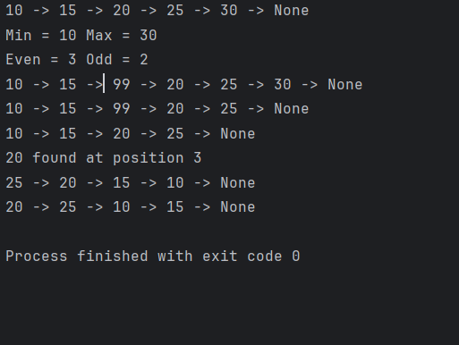
Q2. Doubly Linked List Write a program to perform the following operations on a Doubly Linked List:
1. Append a node at the end of the list. (Easy)
2. Print the list. (Easy)
3. Count total nodes. (Easy)
4. Print node values in reverse order. (Medium)
5. Insert a node at any position of the list. (Medium)
6. Delete a node at a specific position. (Medium)
7. Search for an element in the list, print its position (Medium)
8. Delete alternate nodes. (Hard)
9. Reverse the list. (Hard) answer it in python
ANSWER:
class Node:
def __init__(self, data):
self.data = data
self.prev = None
self.next = None
class DoublyLinkedList:
def __init__(self):
self.head = None
# 1. Append node at end
def append(self, value):
new_node = Node(value)
if self.head is None:
self.head = new_node
return
temp = self.head
while temp.next:
temp = temp.next
temp.next = new_node
new_node.prev = temp
# 2. Print the list
def print_list(self):
temp = self.head
if temp is None:
print("List is empty")
return
print("List:", end=" ")
while temp:
print(temp.data, end=" <-> ")
temp = temp.next
print("None")
# 3. Count total nodes
def count_nodes(self):
count = 0
temp = self.head
while temp:
count += 1
temp = temp.next
print("Total nodes =", count)
# 4. Print list in reverse order
def print_reverse(self):
if self.head is None:
return
temp = self.head
while temp.next:
temp = temp.next
print("Reverse:", end=" ")
while temp:
print(temp.data, end=" <-> ")
temp = temp.prev
print("None")
# 5. Insert at specific position
def insert_at_position(self, value, pos):
new_node = Node(value)
if pos == 1:
new_node.next = self.head
if self.head:
self.head.prev = new_node
self.head = new_node
return
temp = self.head
for _ in range(pos - 2):
if temp is None:
return
temp = temp.next
if temp is None:
return
new_node.next = temp.next
new_node.prev = temp
if temp.next:
temp.next.prev = new_node
temp.next = new_node
# 6. Delete node at specific position
def delete_at_position(self, pos):
if self.head is None:
return
if pos == 1:
self.head = self.head.next
if self.head:
self.head.prev = None
return
temp = self.head
for _ in range(pos - 1):
if temp is None:
return
temp = temp.next
if temp is None:
return
if temp.next:
temp.next.prev = temp.prev
if temp.prev:
temp.prev.next = temp.next
# 7. Search element
def search(self, key):
temp = self.head
pos = 1
while temp:
if temp.data == key:
print(key, "found at position", pos)
return
temp = temp.next
pos += 1
print(key, "not found")
# 8. Delete alternate nodes
def delete_alternate(self):
if self.head is None:
return
temp = self.head.next
while temp:
next_node = temp.next
temp.prev.next = temp.next
if temp.next:
temp.next.prev = temp.prev
temp = next_node.next if next_node else None
# 9. Reverse the list
def reverse(self):
temp = None
current = self.head
while current:
temp = current.prev
current.prev = current.next
current.next = temp
current = current.prev
if temp:
self.head = temp.prev
if __name__ == "__main__":
dll = DoublyLinkedList()
dll.append(10)
dll.append(20)
dll.append(30)
dll.append(40)
dll.append(50)
dll.print_list()
dll.count_nodes()
dll.print_reverse()
dll.insert_at_position(99, 3)
dll.print_list()
dll.delete_at_position(4)
dll.print_list()
dll.search(30)
dll.delete_alternate()
dll.print_list()
dll.reverse()
dll.print_list()
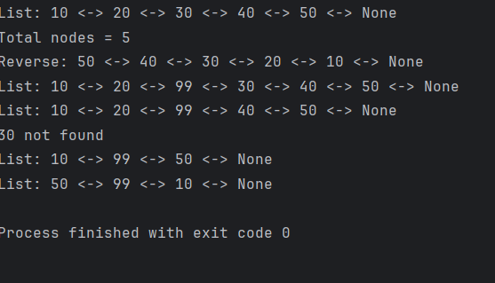
Q3. Stack Write a program to perform the following operations on a Stack:
1. Push an element onto the stack. (Easy)
2. Pop an element from the stack. (Easy)
3. Peek the top element of the stack. (Easy)
4. Reverse the stack using an array. (Medium)
5. Reverse the stack using another stack. (Medium)
6. Reverse a string using stack. (Medium)
7. Check for balanced parenthesis. (Hard)
ANSWER:
class Stack:
def __init__(self):
self.stack = []

# 1. Push
def push(self, item):
self.stack.append(item)
print(item, "pushed")

# 2. Pop
def pop(self):
if self.is_empty():
print("Stack is empty")
return
print(self.stack.pop(), "popped")

# 3. Peek
def peek(self):
if self.is_empty():
print("Stack is empty")
return
print("Top element:", self.stack[-1])

def is_empty(self):
return len(self.stack) == 0

# 4. Reverse stack using array
def reverse_using_array(self):
self.stack = self.stack[::-1]
print("Stack reversed using array")

# 5. Reverse stack using another stack
def reverse_using_stack(self):
temp_stack = []
while self.stack:
temp_stack.append(self.stack.pop())
self.stack = temp_stack
print("Stack reversed using another stack")

# Display stack
def display(self):
print("Stack:", self.stack)

# 6. Reverse string using stack
def reverse_string(s):
st = []
for ch in s:
st.append(ch)

rev = ""
while st:
rev += st.pop()

print("Reversed String:", rev)

# 7. Check balanced parentheses
def is_balanced(expr):
stack = []
pairs = {')': '(', '}': '{', ']': '['}

for ch in expr:
if ch in "({[":
stack.append(ch)
elif ch in ")}]":
if not stack or stack.pop() != pairs[ch]:
print("Not Balanced")
return

print("Balanced" if not stack else "Not Balanced")
if __name__ == "__main__":
s = Stack()
s.push(10)
s.push(20)
s.push(30)

s.display()
s.pop()
s.peek()

s.reverse_using_array()
s.display()

s.reverse_using_stack()
s.display()

reverse_string("VEDIKA")
is_balanced("{[()]}")
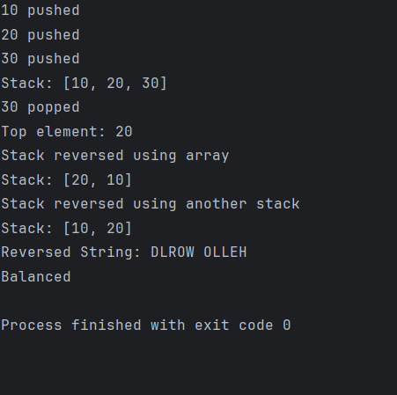
Q4. Linear Queue Write a program to perform the following operations on a Linear Queue:
1. Enqueue an element into the queue. (Easy)
2. Dequeue an element from the queue. (Easy)
3. Peek the front element of the queue. (Easy)
4. Reverse the queue using stack. (Medium)
5. Count no occurrences of an element in a queue. (Medium)
6. Search for an element in the queue. (Medium)
7. Merge two queues into one. (Hard)
8. Check if two queues are identical (Hard)
ANSWER:
class Queue:
def __init__(self):
self.queue = []

# 1. Enqueue
def enqueue(self, item):
self.queue.append(item)
print(item, "enqueued")

# 2. Dequeue
def dequeue(self):
if self.is_empty():
print("Queue is empty")
return
print(self.queue.pop(0), "dequeued")

# 3. Peek
def peek(self):
if self.is_empty():
print("Queue is empty")
return
print("Front element:", self.queue[0])

def is_empty(self):
return len(self.queue) == 0

# Display queue
def display(self):
print("Queue:", self.queue)

# 4. Reverse queue using stack
def reverse_using_stack(self):
stack = []
while self.queue:
stack.append(self.queue.pop(0))
while stack:
self.queue.append(stack.pop())
print("Queue reversed")

# 5. Count occurrences
def count_occurrence(self, key):
count = self.queue.count(key)
print("Occurrences of", key, "=", count)

# 6. Search element
def search(self, key):
if key in self.queue:
print(key, "found at position", self.queue.index(key) + 1)
else:
print(key, "not found")

# 7. Merge two queues
def merge(self, other):
self.queue.extend(other.queue)
print("Queues merged")

# 8. Check identical queues
def is_identical(self, other):
print("Identical" if self.queue == other.queue else "Not Identical")
if __name__ == "__main__":
q1 = Queue()
q1.enqueue(10)
q1.enqueue(20)
q1.enqueue(30)

q1.display()
q1.dequeue()
q1.peek()

q1.reverse_using_stack()
q1.display()

q1.count_occurrence(20)
q1.search(30)

q2 = Queue()
q2.enqueue(40)
q2.enqueue(50)

q1.merge(q2)
q1.display()

q3 = Queue()
q3.queue = [10, 20, 30, 40, 50]

q1.is_identical(q3)
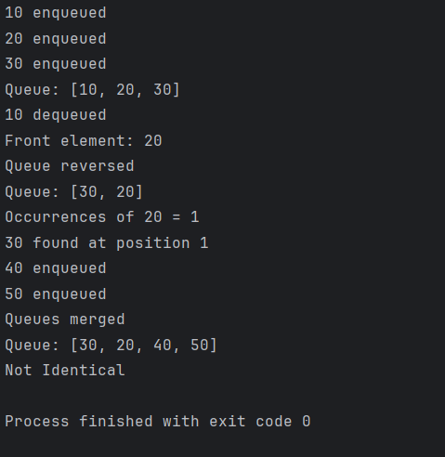
Q5. Priority Queue Write a program to perform the following operations on a Priority Queue:
1. Enqueue an element with a given priority. (Easy)
2. Display Queue. (Easy)
3. Dequeue the element with the highest priority. (Medium)
ANSWER:
class PriorityQueue:
def __init__(self):
self.queue = []

# 1. Enqueue with priority
def enqueue(self, value, priority):
self.queue.append((priority, value))
print(f"{value} inserted with priority {priority}")

# 2. Display queue
def display(self):
if not self.queue:
print("Queue is empty")
return

print("Priority Queue:")
for item in sorted(self.queue, reverse=True):
print(item)

# 3. Dequeue highest priority
def dequeue(self):
if not self.queue:
print("Queue is empty")
return

highest = max(self.queue)
self.queue.remove(highest)
print("Removed element:", highest)
if __name__ == "__main__":
pq = PriorityQueue()

pq.enqueue("A", 2)
pq.enqueue("B", 5)
pq.enqueue("C", 1)

pq.display()
pq.dequeue()
pq.display()
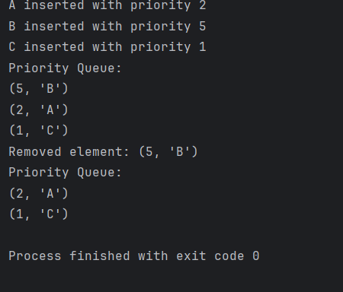
Q6. Binary Search Tree Write a program to perform the following operations on a Binary Search Tree:
1. Insert a node into the BST. (Easy)
2. Find the minimum value in the BST. (Easy)
3. Find the maximum value in the BST. (Easy)
4. Search for a specific node and print its level. (Medium)
5. Count the number of nodes in the BST. (Medium)
6. Count the number of nodes in the left subtree. (Medium)
7. Count the number of nodes in the right subtree. (Medium)
8. Delete the specific node. (Hard)
ANSWER:
class Node:
def __init__(self, data):
self.data = data
self.left = None
self.right = None

class BST:
def __init__(self):
self.root = None

# 1. Insert node
def insert(self, value):
self.root = self._insert(self.root, value)

def _insert(self, root, value):
if root is None:
return Node(value)
if value < root.data:
root.left = self._insert(root.left, value)
elif value > root.data:
root.right = self._insert(root.right, value)
return root

# 2. Find minimum
def find_min(self):
current = self.root
while current.left:
current = current.left
print("Minimum value:", current.data)

# 3. Find maximum
def find_max(self):
current = self.root
while current.right:
current = current.right
print("Maximum value:", current.data)

# 4. Search node and print level
def search_level(self, value):
level = 1
current = self.root

while current:
if value == current.data:
print(value, "found at level", level)
return
elif value < current.data:
current = current.left
else:
current = current.right
level += 1

print(value, "not found")

# 5. Count total nodes
def count_nodes(self, root):
if root is None:
return 0
return 1 + self.count_nodes(root.left) + self.count_nodes(root.right)

# 6. Count left subtree nodes
def count_left_subtree(self):
print("Left subtree nodes:", self.count_nodes(self.root.left))

# 7. Count right subtree nodes
def count_right_subtree(self):
print("Right subtree nodes:", self.count_nodes(self.root.right))

# 8. Delete node
def delete(self, value):
self.root = self._delete(self.root, value)

def _delete(self, root, value):
if root is None:
return root

if value < root.data:
root.left = self._delete(root.left, value)
elif value > root.data:
root.right = self._delete(root.right, value)
else:
if root.left is None:
return root.right
elif root.right is None:
return root.left

temp = self._min_value_node(root.right)
root.data = temp.data
root.right = self._delete(root.right, temp.data)

return root

def _min_value_node(self, node):
current = node
while current.left:
current = current.left
return current
if __name__ == "__main__":
bst = BST()

for val in [50, 30, 70, 20, 40, 60, 80]:
bst.insert(val)

bst.find_min()
bst.find_max()

bst.search_level(60)

print("Total nodes:", bst.count_nodes(bst.root))
bst.count_left_subtree()
bst.count_right_subtree()

bst.delete(70)
print("Node 70 deleted")
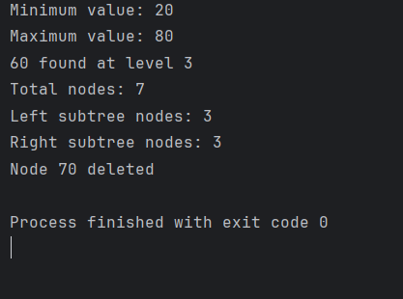
Q7. Algorithms
- Write a program to search element using Binary search
ANSWER:
def binary_search(arr, key):
low, high = 0, len(arr) - 1

while low <= high:
mid = (low + high) // 2
if arr[mid] == key:
return mid
elif arr[mid] < key:
low = mid + 1
else:
high = mid - 1

return -1

arr = [10, 20, 30, 40, 50]
key = 30

result = binary_search(arr, key)
print("Found at index" if result != -1 else "Not found", result)
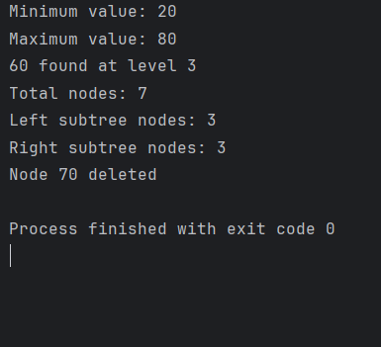
- Write a program to generate Pascal Triangle
ANSWER:
def pascal_triangle(n):
for i in range(n):
num = 1
for j in range(i + 1):
print(num, end=" ")
num = num * (i - j) // (j + 1)
print()

pascal_triangle(5)
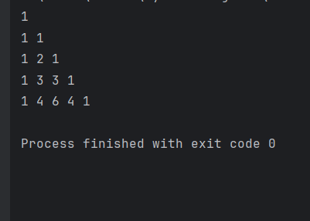
- Write a program of Tower of Hanoi for n=3
Answer:
def tower_of_hanoi(n, source, auxiliary, destination):
if n == 1:
print("Move disk 1 from", source, "to", destination)
return

tower_of_hanoi(n - 1, source, destination, auxiliary)
print("Move disk", n, "from", source, "to", destination)
tower_of_hanoi(n - 1, auxiliary, source, destination)

tower_of_hanoi(3, "A", "B", "C")
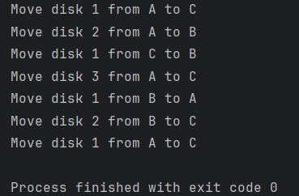
- Write a program to find GCD using Euclidean Algorithm
ANSWER:
def gcd(a, b):
while b != 0:
a, b = b, a % b
return a

print("GCD =", gcd(48, 18))
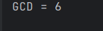
- Write a program to sort elements in the list using Merge Sort
ANSWER:
def merge_sort(arr):
if len(arr) <= 1:
return arr
mid = len(arr) // 2
l_half = arr[:mid]
r_half = arr[mid:]
l_half = merge_sort(l_half)
r_half = merge_sort(r_half)
return merge(l_half, r_half)
def merge(left, right):
new = []
i, j = 0, 0
while i < len(left) and j < len(right):
if left[i] < right[j]:
new.append(left[i])
i += 1
else:
new.append(right[j])
j += 1
new.extend(left[i:])
new.extend(right[j:])
return new
arr = [38, 27, 43, 3, 9, 82, 10]
print("Original array:", arr)
sorted_arr = merge_sort(arr)
print("Sorted array:", sorted_arr)
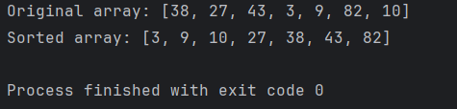
- Write a program to sort elements in the list using Quick Sort
ANSWER:
def quick_sort(arr):
if len(arr) <= 1:
return arr

pivot = arr[0]
left = [x for x in arr[1:] if x <= pivot]
right = [x for x in arr[1:] if x > pivot]

return quick_sort(left) + [pivot] + quick_sort(right)

arr = [10, 7, 8, 9, 1, 5]
print("Sorted:", quick_sort(arr))
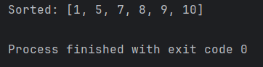
- Write a program to implement Jump Game
ANSWER:
def jumps(nums):
jump=0
curr_end=0
farthest=0
for i in range(len(nums)-1):
farthest=max(farthest,i+nums[i])
if i==curr_end:
jump+=1
curr_end=farthest
return curr_end>=len(nums)-1
print(jumps([1,0,2,4,5]))
print(jumps([2,1,3,4,0,1]))
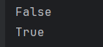
- Write a program to find unique paths for m*n matrix
ANSWER:
def unique_paths(m, n):
dp = [[1] * n for _ in range(m)]

for i in range(1, m):
for j in range(1, n):
dp[i][j] = dp[i - 1][j] + dp[i][j - 1]

return dp[m - 1][n - 1]

print("Unique paths:", unique_paths(3, 3))



